Online Learning 201: Creating Course Content in D2L and Ensuring Accessibility

Training Video
Watch Zoom hands-on training session: https://youtu.be/A81L0j0lUgA

Creating Course Content
- Watch Overview: https://youtu.be/CTdLtnPy7o4
- Watch HTML Editor (Adding links, photos, video embed): https://www.youtube.com/watch?v=oBtdlm3Ovx8

Ensuring Accessibility

Resource Links
- https://webaccess.msu.edu
- https://webaccess.msu.edu/Help_and_Resources/checklist.html
- https://www.rcpd.msu.edu

Basic Tips
- Text Contrast: Use black text on a white background to ensure that the text stands out on the page.
- Text Styles: Do not rely on color alone to denote differences in emphasis and content meaning.
- Heading Styles: Use built-in heading styles to designate content organization.
- List Styles: Use the built-in bullet or number styles for lists.
- Alt Text: Provide a brief text alternative for images, graphs, and charts that answers the question: why is this image important?
- Closed Captioning: Captioning your media provides greater student comprehension of the material covered and provides access to media for individuals with hearing impairments in compliance with federal regulations.
- Link Text: Use descriptive titles for link text, titles, and headers.
- Tables: use simple tables when possible, with column and row headers.

Uploading a Video to Kaltura MediaSpace
Kaltura Mediaspace is the prefered method for hosting captioned media content at MSU. Every faculty member is automatically given a Kaltura MediaSpace account based on their MSU NetID and can access it by going to the link below:
http://mediaspace.msu.edu
- Begin by uploading your video content to Kaltura MediaSpace. Once you are logged into Kaltura MediaSpace using your MSU NetID, click Add New, then the Media Upload button on the drop-down.
- Next, click Choose a file to upload, and select the video file that you would like to upload.
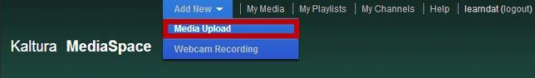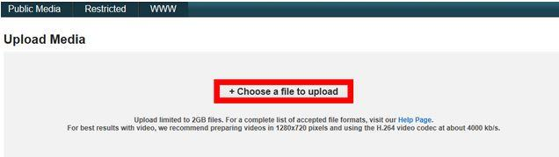
Note: There is an upload limit of 2GB per file. The dialog above provides recommendations for the best file size and format.
3. Next, title and describe your video. Your title should be relevant and easy to understand so that it easy to find later. Providing a description is also a good idea, especially if you have multiple videos concerning the same topic. Tagging your video is important for searching by keyword/topic. Click Save when you are done
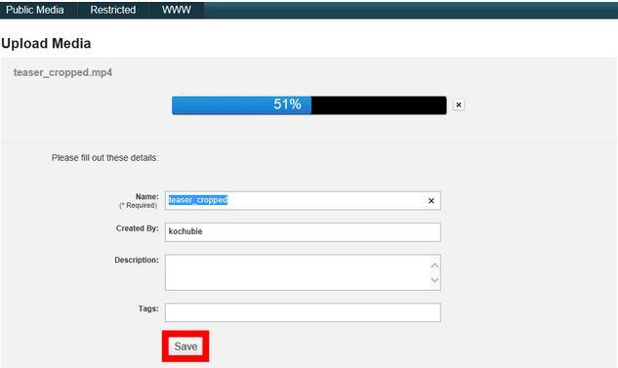
4. Now that your video is uploaded, you will notice a list of thumbnails that represent your uploaded video archive. The video you just uploaded should appear below the list.

Ordering Captions from REV
https://apps.d2l.msu.edu/kaltura/captions/
- Begin by logging onto the Caption Order Form
- Chose the Rev radio button
- Next, select your video
- Individual Video or All Videos
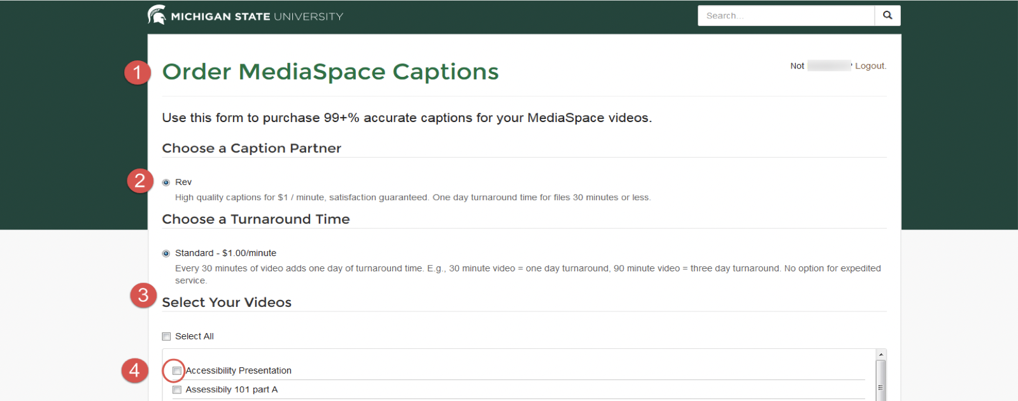

Billing
1. Account Number 2. Course
3. Order
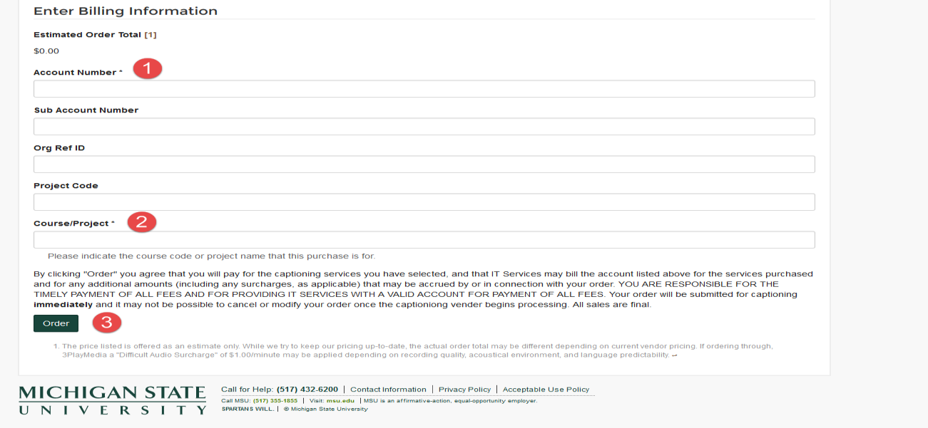

The Basic Toolkit

Microsoft 365 Basic Toolkit for Faculty and Students
- Microsoft 365: Make documents/presentations/spreadsheets, etc.
  - All students and faculty have free licenses for Microsoft Office.
  - All students are able to access and create these file types.
  - You can log in with your MSU NetID to use the web version or to download current versions from https://portal.office.com/.

Support
- For additional support, the MSU Service Desk is open 24/7 to help you transition to remote teaching:
- Call local: 517-432-6200, toll-free: 844-678-6200
- Chat: go.msu.edu/itchat
- Email: ithelp@msu.edu

