Online Teaching 401: Using Video

Training Video
Watch Zoom hands-on training session: https://youtu.be/08wM0P94Bp0

Zoom
Zoom is a cloud-based solution for video and audio conferencing, mobile collaboration, and online meetings and Webinars. Zoom web-based conferencing uses video and audio and is accessible on MacOS, Windows, iOS and Android mobile devices. Additionally, Zoom can be used with conventional phone lines for audio conferencing.

If campus is in modified operations, you can set up a virtual meeting through Zoom. Every MSU faculty, staff and student has free access to Zoom Pro Meeting with up to 300 participants and Zoom Webinar with up to 500 participants. Go to msu.zoom.us to get started.

Set up a Zoom Link
Through Zoom, you can set up a calendar event for your meeting and invite all your attendees, with whom a link will be automatically shared. If you need more information on how to get started with Zoom, visit: https://support.zoom.us/hc/en-us/categories/200101697.

Record Your Meeting
You can record your virtual meeting for staff who are not able to attend. X Read or watch how to record it on the Zoom website: https://go.msu.edu/zoomrecording.

If you anticipate that you will exceed 300, please contact the MSU IT Help Desk to be granted extended capacity at no cost: (517) 432-6200 or ithelp@msu.edu.

For frequently asked questions, visit the MSU IT Knowledge Base.

For Larger Groups on Zoom

Watch: https://youtu.be/j_O7rDILNCM

Breakout Rooms allow you to split your Zoom meeting in up to 50 separate sessions. The meeting host can choose to split the participants of the meeting into these separate sessions automatically or manually, and can switch between sessions at any time.
- Up to 50 breakout rooms can be created
- Max 200 participants in a breakout room (requires Large Meeting add-on)
- Breakout room participants have full audio, video and screen share capabilities

If the meeting is being cloud recorded, it will only record the main room, regardless of what room the meeting host is in. If local recording is being used, it will record the room the participant who is recording is in. Multiple participants can record locally.

Comprehensive Resources on Breakout Rooms: https://support.zoom.us/hc/en-us/articles/206476093-Getting-Started-with-Breakout-Rooms

MediaSpace Basics
Upload Media: https://knowledge.kaltura.com/help/uploading-and-ingestion#upload-media
Ordering Captions: https://knowledge.kaltura.com/help/reach---ordering-captions-for-media-per-entry

Uploading a Video to Kaltura MediaSpace
Kaltura Mediaspace is the prefered method for hosting captioned media content at MSU. Every faculty member is automatically given a Kaltura MediaSpace account based on their MSU NetID and can access it by going to the link below:
http://mediaspace.msu.edu
- Begin by uploading your video content to Kaltura MediaSpace. Once you are logged into Kaltura MediaSpace using your MSU NetID, click Add New, then the Media Upload button on the drop-down.
- Next, click Choose a file to upload, and select the video file that you would like to upload.
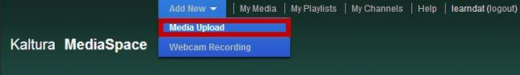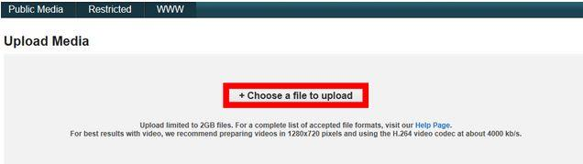
Note: There is an upload limit of 2GB per file. The dialog above provides recommendations for the best file size and format.
3. Next, title and describe your video. Your title should be relevant and easy to understand so that it easy to find later. Providing a description is also a good idea, especially if you have multiple videos concerning the same topic. Tagging your video is important for searching by keyword/topic. Click Save when you are done
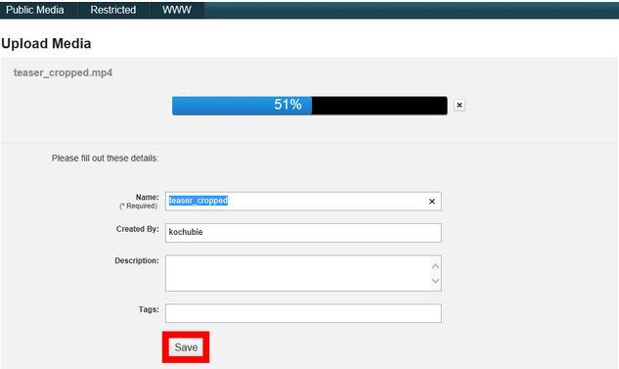
4. Now that your video is uploaded, you will notice a list of thumbnails that represent your uploaded video archive. The video you just uploaded should appear below the list.

Ordering Captions from REV
https://apps.d2l.msu.edu/kaltura/captions/
- Begin by logging onto the Caption Order Form
- Chose the Rev radio button
- Next, select your video
- Individual Video or All Videos
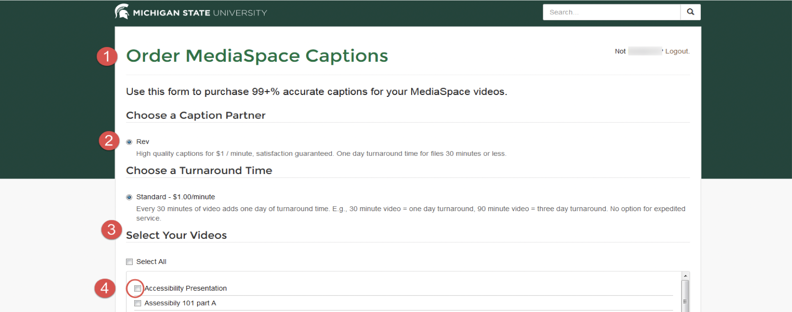

Billing
1. Account Number 2. Course
3. Order
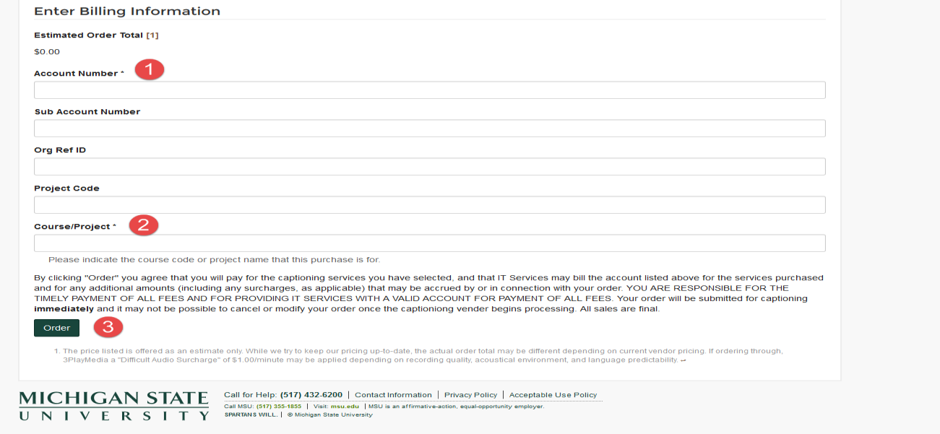

Ordering 3 Party Video Captions Using MediaSpace

- Access MediaSpace using this link to the MSU Mediaspace
- Login by clicking “Guest” at the top right of the site and then click “Login” in the dropdown menu
- Click “Add New” at the top of the site and then click “Media Upload” in the dropdown menu
- Then click “Choose a file to upload” and select the video files to be captioned.
- Name the files using a format of “Course-name + module/week number + video topic”
  - Example: CSS 200 Week 1 Intro
- Click “Save” after you have titled your videos
- Your videos will soon be published to MediaSpace and now will just need to be uploaded to Rev to receive captions
- Use the Order MediaSpace Captions link to order captions through Rev
- Under the heading “Select Your Videos” check all the videos that you want to order captions for
- Under the heading “Enter Billing Information” enter your account number in the “account number” field, then enter your course code under the “Course/Project” field
- Once you have completed this, click “Order”
- After you order the captions the Videos will be processed and should be done within 24-48 hours

KMS Go App

Kaltura also has created an app you can use to create and curate content. Many use this to record on a mobile device and directly upload to share.
Watch Video Tutorial Overview: https://mediaspace.msu.edu/media/CAS+832A+KMS+Go+App+Tutorial/1_8rqp7ay2

Microsoft Teams

- Microsoft Teams is a program available through Spartan 365 that allows users to chat, video conference, share files, and collaboratively work on projects. It is one of the most useful tools available when working remotely. Access Teams at spartan365.msu.edu or to request a team or learn more about teams, visit Microsoft Teams.
- Set up a Teams meeting
  - If you are a member of a Microsoft Team, you can schedule a meeting in teams. Teams meetings support up to 250 people.
- Record your meeting
  - If you are a member of a Microsoft Team, you can record your meeting.

The Basic Toolkit

Microsoft 365 Basic Toolkit for Faculty and Students
- Microsoft 365: Make documents/presentations/spreadsheets, etc.
  - All students and faculty have free licenses for Microsoft Office.
  - All students are able to access and create these file types.
  - You can log in with your MSU NetID to use the web version or to download current versions from https://portal.office.com/.

Support
- For additional support, the MSU Service Desk is open 24/7 to help you transition to remote teaching:
- Call local: 517-432-6200, toll-free: 844-678-6200
- Chat: go.msu.edu/itchat
- Email: ithelp@msu.edu

